**3.9.1 Exercises**

1. Turn a stacked bar chart into a pie chart using coord_polar().

A pie chart is a stacked bar chart with the addition of polar coordinates.

Take this stacked bar chart with a single category.

ggplot(mpg, aes(x = factor(1), fill = drv)) +

geom_bar()

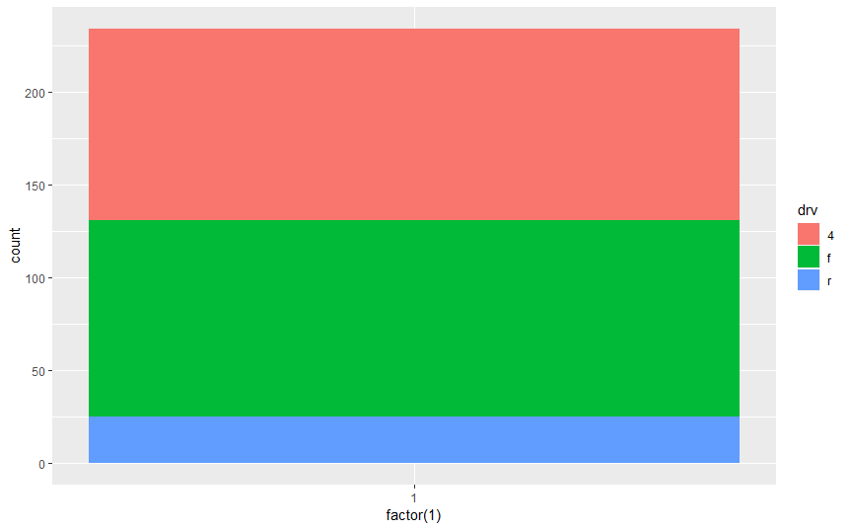

ggplot(mpg, aes(x = factor(1), fill = drv)) +

geom_bar(width = 1) +

coord_polar(theta = "y")

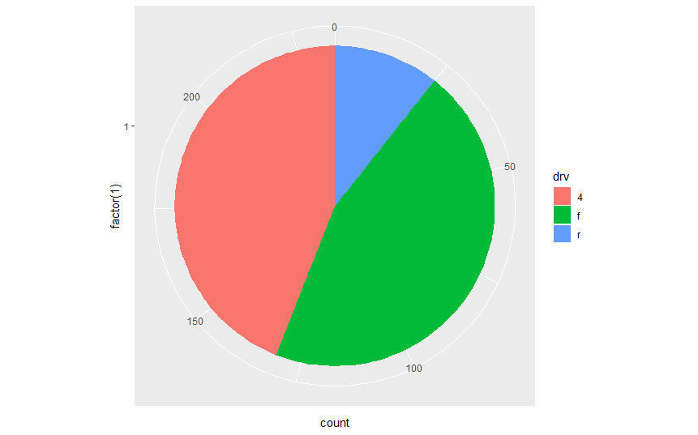

The argument `theta = "y"` maps `y` to the angle of each section.

If `coord_polar()` is specified without `theta = "y"`, then the resulting plot is called a bulls-eye chart.

1. What does labs() do? Read the documentation.

The `labs` function adds axis titles, plot titles, and a caption to the plot.

ggplot (data = mpg, mapping = aes(x = class, y = hwy)) +

geom_boxplot() +

coord_flip() +

labs (y = "Highway MPG", x = "Year",

title = "Highway MPG by car class",

subtitle = "1999-2008",

caption = "Source: <http://fueleconomy.gov>")

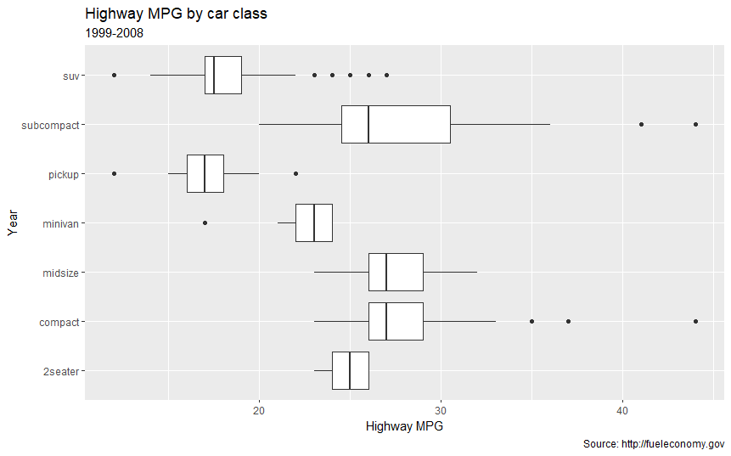

The arguments to `labs()` are optional, so you can add as many or as few of these as are needed.

The `labs()` function is not the only function that adds titles to plots.

The `xlab()`, `ylab()`, and x- and y-scale functions can add axis titles.

The `ggtitle()` function adds plot titles.

1. What’s the difference between coord_quickmap() and coord_map()?

The `coord_map()` function uses map projections to project the three-dimensional Earth onto a two-dimensional plane.

This projection is applied to all the geoms in the plot.

The `coord_quickmap()` function uses an approximate but faster map projection.

This approximation ignores the curvature of Earth and adjusts the map for the latitude/longitude ratio.

The `coord_quickmap()` project is faster than `coord_map()` both because the projection is computationally easier, and unlike `coord_map()`, the coordinates of the individual geoms do not need to be transformed.

1. What does the plot below tell you about the relationship between city and highway mpg? Why is coord_fixed() important? What does geom_abline() do?

**ggplot**(data = mpg, mapping = **aes**(x = cty, y = hwy)) +

**geom_point**() +

**geom_abline**() +

**coord_fixed**()

The function `coord_fixed()` ensures that the line produced by `geom_abline()` is at a 45-degree angle.

A 45-degree line makes it easy to compare the highway and city mileage to the case in which city and highway MPG were equal.

If we didn't include `geom_coord() `, then the line would no longer have an angle of 45 degrees.

The abline geom adds a line with specified slope and intercept to the plot.